A Painting Purported to Depict Abraham Clark, a Signer of the Declaration of Independence
from New Jersey, and His Family: An Object Case Study

By Joseph W. Hammond
DOI: 10.14713/njs.v11i1.389
The Challenge
A painting in the collection of the National Gallery of Art in Washington, DC, is titled Abraham Clark and His Family. Executed in oil on a yellow poplar wood panel, it measures 25.5 by 32 inches. It is signed “JH” conjoined on the reverse and is also dated “April / 29, 1822.” The work depicts an adult male wearing a top hat posed in a landscape setting with six children. The painting was a 1953 gift to the National Gallery by renowned American folk art collectors Edgar William and Bernice Chrysler Garbisch. They had acquired it in 1947 from H. Gregory Gulick, an antiques dealer from Middletown, New Jersey. It was accompanied by a handwritten note that reads, “Aldene, N. J. Nov. 29/43, The history of the Primitive Painting of Mr. Clark and his family – it has been in this house for about sixty years – and owned by Mrs. Cora Clark and her husband Edward Clark – and owned by Edward Clark Grandfather (Abraham Clark). It is said that he was one of the signers of the Declaration of Independence. The Clark family was one of the oldest families in New Jersey. The painting was sold . . .” Unfortunately, the bottom of the note has been torn off, presumably by Gulick to protect the confidentiality of his source.
Paintings, furnishings, and artifacts of every description associated with the founders of the United States have always been viewed as highly collectible by museums, historical
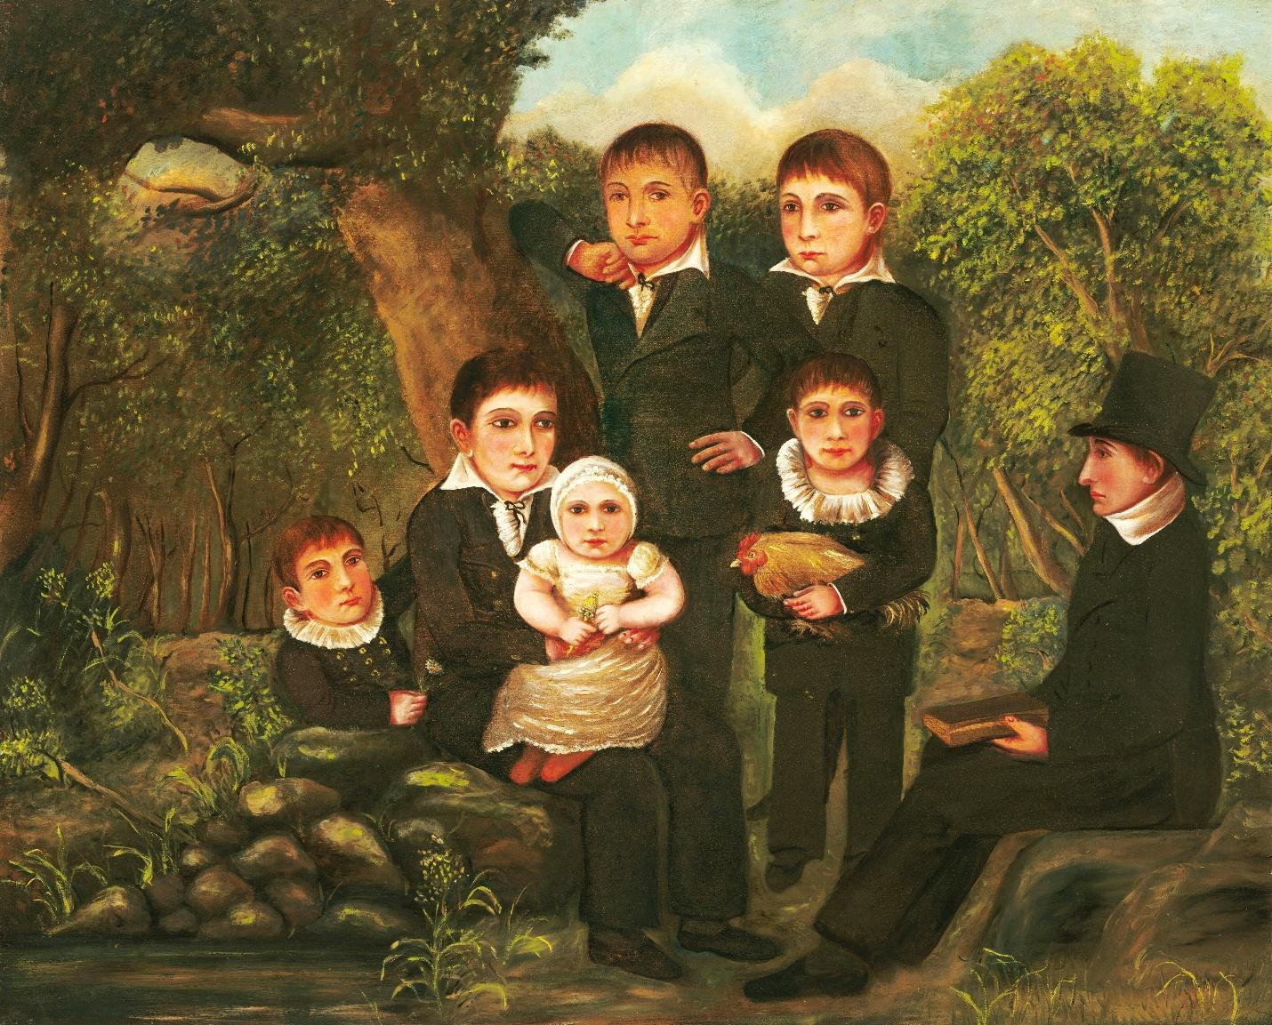
Abraham Clark and His Children, oil on wood panel, 25.5 by 32 inches, signed “JH”
conjoined and dated “April / 29, 1822” on the reverse. Courtesy National Gallery of Art, Washington, DC,
gift of Edgar William and Bernice Chrysler Garbisch, 1953.

societies, and private individuals. Approximately 500 such items representative of the Revolutionary era in New Jersey were brought together in 1976 for a major Bicentennial exhibit titled The Pulse of the People: New Jersey, 1763–1789. The catalog of that milestone exhibit remains an important reference work for students of New Jersey history and material culture. A portrait of Abraham Clark would certainly have fallen into this desirable collecting category. Clark, who was born on February 15, 1726, in what is now Roselle, New Jersey, became a vocal proponent of democracy and the common man, supporting especially the societal roles of farmers and mechanics. On June 21, 1776, the Provincial Congress appointed him a delegate to the Continental Congress, along with John Hart, Francis Hopkinson, Richard Stockton, and John Witherspoon. They arrived in Philadelphia, Pennsylvania, on June 28, 1776, replacing a slate of New Jersey delegates that opposed independence from Great Britain. Clark and his colleagues then voted for the Declaration of Independence in early July. Clark later served on the New Jersey Legislative Council, and in 1791 was elected to the US House of Representatives. He died at his home in Roselle on September 15, 1794, and was buried in the Rahway Cemetery.
Art historians have long since dismissed the belief that the painting at the National Gallery depicts Abraham Clark, the signer, as he died in 1794 at the age of 68, and the painting is dated 1822. Nonetheless, a New Jersey museum preparing an upcoming exhibit on the state’s five signers of the Declaration of Independence attempted unsuccessfully to determine if the subjects in the painting were some of Clark’s descendants. Efforts to also connect Edward Clark to the signer through further family research ran into abrupt challenges. The quest was made more difficult because several Edward Clarks lived in the vicinity of Plainfield, New Jersey, during the first half of the twentieth century, and many more resided throughout northern New Jersey. A renewed effort to identify Edward and Cora Clark therefore began with Cora. A newspaper account of her 1923 wedding to Edward Clark provided the address of their home: 433 East Fifth Street in Plainfield. Key word searches using the address then helped to identify the correct Edward Clark. The story that follows resulted from extensive research in Ancestry.com, FamilySearch.com, and Newspapers.com. The latter proved to be critically useful as the entire run of the Plainfield Courier-News newspaper from 1884 on has been digitized and made available in searchable format on that website.
Findings
Cora Naylor (also spelled Neilor interchangeably) Clark was born in Bound Brook, New Jersey, on April 2, 1881, a daughter of Jonathan R. D. Neilor (1845–1881) and his wife Laura E. Linbarger (1849–1917). The couple had been married in Plainfield, New Jersey, on July 29, 1872. Laura was the daughter of William and Emma Linbarger. Cora was the youngest of the Naylors’ four daughters who survived to adulthood. At the time of the 1880 Federal census, the family was living in Bridgewater, New Jersey, where Jonathan had been born and raised by his parents, Andrew H. Naylor and Caroline R. Dunham. He was age 35 and employed as a wheelwright. Although born in Philadelphia, Laura had been a nearly lifelong resident of the Plainfield area and was a long-standing member of the Hope Presbyterian Chapel there.
Following the death of Jonathan Naylor in 1881, the five female Naylors appeared in the 1885 New Jersey census as living on Pearl Street in North Plainfield. Laura Naylor remarried by 1888 to Henry L. Southard (1839–1922) of Plainfield, by whom she had two sons. Cora Naylor married on October 27, 1923, to Edward Clark. The wedding took place at the bride’s residence at 116 West Front Street in Plainfield, with the pastor of the Hope Presbyterian Chapel performing the ceremony. It was followed by an elaborate reception at the groom’s home at 433 East Fifth Street in Plainfield that featured an orchestra and supper provided by a New York caterer. After a honeymoon trip, the couple took up residence in Clark’s home. The wedding was reported at length in the Plainfield Courier-News. The article spelled the bride’s name as Neilor.
Cora Naylor Clark died in Plainfield on August 7, 1937, after an illness requiring a blood transfusion at the Muhlenberg Hospital. She was survived by her husband, Edward Clark, and a stepdaughter, Edna Frances Clark, who had married Walter Jennings Crookall in Plainfield in June of 1931. This, of course, means that Edward Clark had been married previously. The 1905 New Jersey census confirms this, listing Edward Clark, age 27 and born in December 1878 in New York, along with wife, Ida, born in New Jersey in July 1881 and age 23, then living in North Plainfield. Clark’s parents had both been born in England. The 1910 Federal census for Plainfield continues the story. It lists Edward H. Clark, age 32, born in New York; Ida F. Clark, age 28, born in New Jersey; and Edna F. Clark, age 1, born in New Jersey. They were boarders at the time. The census schedule again indicates that Edward’s parents were both born in England. The 1920 Federal census repeats much of this information, including the English origin of Clark’s parents. At the time, he was working as a machinist. Edward Clark was listed as age 39, his wife Ida at 37, and daughter Edna at 11 years old. Ida Frances Clark died on 22 March 1920. Her husband applied for the administration of her estate on April 20, 1920.
Other documents, including a 1942 draft registration card listing his daughter, Edna, as next of kin and a 1945 claim for social security benefits, indicated that Edward Clark was born on December 18, 1878, in Brooklyn. The 1880 Federal census provides the following information: his father was George Clark, age 36, born in England of English parents. He was employed as a car conductor (probably railroad but also possibly streetcar or elevated). Edward’s mother was named Julia, also born in England of English parents. Edward was the youngest of their six children. The three oldest were born in England. The fourth, a son named Walter, age 5, was born in New York. This means that the family emigrated to America before 1874 or 1875. At the time of the census, the Clarks were living on Jackson Place in Brooklyn, a neighborhood of modest working-class row houses located between Greenwood Cemetery and Prospect Park.
Anna M. Wuergler Hoover became Edward Clark’s third wife. Her first husband, Walter T. Hoover, had died on April 21, 1939, at the age of 46. Anna Clark died on February 16, 1952, at the age of 59. She was a daughter of Rudolph and Katherine Wuergler of Plainfield.
Edward Clark, still officially a resident at 433 East Fifth Street, died on September 9, 1952, at the Bonnie Burn Sanatorium in Berkeley Heights, New Jersey, age 73. His obituary noted that he was a retired machinist who had been employed for 25 years each by Walter Scott & Co. Inc., and the Wood Newspaper Machinery Corp. He was a member of the Benevolent Lodge 256, Junior Order of United American Mechanics, in Plainfield. Clark’s surviving relatives were his daughter Edna Pellegrim of Newark (her second husband was Ernest M. Pellegrim), and a brother, Walter Clark of Brooklyn. The funeral was conducted by the minister of the Monroe Avenue Methodist Church. Interment took place at Cypress Hills Cemetery on Long Island.
Conclusions
- Census records indicate that Edward Clark’s four grandparents, parents, and three of his older siblings were all born in England. This makes it highly unlikely that Clark was in any way related to the Clark family of New Jersey.
- The handwritten note claiming that Edward Clark was a descendant of Abraham Clark, a signer of the Declaration of Independence from New Jersey, was clearly a complete fabrication, no doubt created to make the painting more desirable to a noted antiques dealer like H. Gregory Gulick and prominent collectors like Edgar William and Bernice Chrysler Garbisch.
- The unidentified person who acquired the painting and sold it to H. Gregory Gulick, presumably in 1943, appears to have obtained it from Edward and Cora Clark before her death in 1937.
- The 1943 claim that the painting had been in the house of the seller for 60 years is not credible. That would place it there as early as 1883. Edward and Cora Clark were not married until 1923, and Edward Clark and his first wife Ida were noted as boarders in the 1910 Federal census.
- Edward and Cora Clark never lived in Aldene, New Jersey. It was likely the residence of the person, perhaps an antiques dealer, who acquired the painting from the Clarks.
- Given the working-class status of Edward Clark and his father, George Clark, it seems unlikely that the painting was brought from England when the family emigrated to New York before 1874 or 1875, especially given its large size.
- The painting was executed on a wood panel of yellow poplar, a soft wood also known as tulip poplar and several other names. It is native to the eastern United States from Connecticut to Florida. This implies an American origin for the painting.
- Two of Edward Clark’s three wives were of German American background. The family history of his first wife, Ida, is not known at this time. It is entirely possible that the painting descended in the families of either Ida or Cora Naylor Clark.
- If the painting was indeed inherited by one of Edward Clark’s wives, then it almost certainly does not depict members of the Clark family of New Jersey.
Joseph W. Hammond conducts research and writes on New Jersey history topics from his retirement home in northern New Hampshire. His interests include decorative and fine arts, architecture, and social history. A resident of Freehold for more than 40 years, he has, in the past, served the Monmouth County Historical Association as executive director, consulting archivist, curator of museum collections, and director of collections. Hammond holds a BA in American history and civilization from Boston University and an MA in history museum studies from the Cooperstown Graduate Program of the State University of New York at Oneonta. He can be reached by email at jwhammond@aol.com.

For a detailed discussion of this painting and its possible symbolism, see Deborah Chotner et al, American Naïve Paintings: National Gallery of Art, Washington (Washington, DC: National Gallery of Art and Cambridge University Press, 1992), 160–162.
Curatorial File, Abraham Clark and His Children, accession number 1953.5.40 (1251), National Gallery of Art, Washington, DC.
The Pulse of the People: New Jersey, 1763–1789. Trenton: New Jersey State Museum, 1976.
For a detailed biography of Clark, see: Ruth Bogin, Abraham Clark and the Quest for Equality in the Revolutionary Era, 1774–1794 (Rutherford, New Jersey: Fairleigh Dickinson University Press, 1982).
New Jersey Marriages, 1871 - 1872, Paterson to Warren, 848. Ancestry.com, accessed July 27, 2024.
1880 U. S. Population Census Schedules, New Jersey, Somerset County, Bridgewater Township, First District, 22. Ancestry.com, accessed July 27, 2024.
“Paralysis Fatal to Mrs. Laura Southard,” Courier-News (Plainfield, New Jersey), February 26, 1917, 1 (hereafter Courier-News).
1885 New Jersey State Census Schedules, Somerset County, North Plainfield Township, 37. Ancestry.com, accessed July 27, 2024.
“Miss Neilor Bride of Edware Clark,” Courier-News, October 30, 1923, 12.
“Miss Edna Clark Becomes Bride of Walter J. Crookall,” Courier-News, June 16, 1931, 12, “Mrs. Edward Clark Dead After 7 Weeks’ Illness,” August 7, 1937, 1, and “Mrs. Edward Clark Rites Tomorrow,” August 9, 1937, 6.
1905 New Jersey State Census Schedules, Somerset County, North Plainfield Township, First District, Sheet Two. Ancestry.com, accessed July 28, 2024.
1910 U. S. Population Census Schedules, New Jersey, Union County, Plainfield City, Fourth Ward, Second District, Sheet Two. Ancestry.com, accessed July 28, 2024.
1920 U. S. Population Census Schedules, New Jersey, Union County, Plainfield City, Ward 2, Sheet 3. Ancestry.com, accessed July 28, 2024.
”Clark,”Courier-News, March 24, 1920, 13, and “Administration Papers Applied For,” April 20, 1920, 12.
U. S. World War II Draft Registration Card, Edward Clark, 1942. Ancestry.com, accessed July 29, 2024.
U. S. Social Security Applications and Claims Index, Edward Clark, September 18, 1945. Ancestry.com, accessed July 29, 2024.
1880 U. S. Population Census Schedules, New York, Kings County, 7th District, 22nd Ward, 268. Ancestry.com, accessed July 29, 2024.
“Walter T. Hoover Dies at 46.” Courier-News, April 22, 1939, 2.
“Mrs. Edward Clark,” Courier-News, February 18, 1952, 9.
“Edward Clark,” Courier-News, September 10, 1952, 44.

