‘“The Battle of Monmouth 2.0: George Washington and Warehouses on Revolutionary War Site in Upper Freehold, New Jersey”

By Sue Kozel
DOI: 10.14713/njs.v11i1.378
Abstract: This article examines ongoing efforts to preserve a Revolutionary War–era British encampment site in Upper Freehold, New Jersey, that is currently threatened by proposed warehouse development. The author, a public historian, details the historical significance of the site as part of the 1778 Battle of Monmouth campaign and describes community activism to protect it ahead of America’s 250th anniversary in 2026. Key aspects covered include: historical evidence confirming the site’s role in the Revolutionary War; public history and preservation strategies employed by local advocates; debates over the site’s historical importance and interpretation; connections to broader Revolutionary War history in New Jersey; inclusion of African American and Native American perspectives; and the ongoing political and legal battles over the site’s future. The case study illustrates challenges in preserving Revolutionary War sites, engaging public memory, and balancing development pressures with historic preservation. It argues for the site’s importance to New Jersey and American history as the nation approaches its semiquincentennial.

Public historians and history advocacy organizations bring traditional historical scholarship in creative ways to the greater public to help prepare for and celebrate America 250. By drawing on images, heritage tourism signage, historical and recreated maps, and interpretive historical text, public histories make diverse, inclusive, and documented history accessible to millions of people outside of traditional history networks. With the 2026 Semiquincentennial
celebration of the independence of the United States from England, New Jersey communities will be catching “Revolutionary Fever.”
This paper will highlight some of my findings presented during the November 17, 2023, “Unfinished Revolution” conference on preservation efforts and public history programs to advocate for Revolutionary War history along with important updates. Our featured panel showcased the work of three women engaged in public history programming and research: moderator Ashley Abruzzo, Heritage Tourism Manager, Crossroads of the American Revolution; Julia M. Diddell, State Washington-Rochambeau Revolutionary Route New Jersey (W3R-NJ); and me, a public historian, retired history adjunct professor, and member of Allentown 250. This article updates my presentation with developments over the past year involving preservation strategies of land commonly known as “the Stein Property,” sixty acres of land in Upper Freehold bordering Allentown, its neighbor. At the time of publication submission, staff in Governor Murphy’s office spanning over two departments and divisions had met via Zoom, phone calls, and emails with me, Monmouth County Commissioner Ross Licitra, and/or Executive Director for Monmouth County Parks Andrew Spears, for the purpose of exploring a public-private partnership between New Jersey, Monmouth County, and/or others to preserve the Upper Freehold British Encampment tied to the 1778 Battle of Monmouth as part of America 250, Revolutionary NJ 250, and Monmouth 250. As of April 2, 2025, the New Jersey Gubernatorial campaign has factored into the Stein preservation debate, and gubernatorial candidates have taken stands: Democrat Steven Fulop is calling for a moratorium on warehouses in an executive order when he is governor, and he opposes the mega warehouses from destroying farmland and the Revolutionary War site on the Upper Freehold Stein property that borders Allentown, New Jersey. Democrat Mikie Sherrill called for a warehouses moratorium after Fulop. Former Republican candidate Ed Durr supported historic preservation at the Stein property. Additionally, legislation has been introduced to prevent large warehouses from encroaching on historic districts within 1,000 ft.
The role historical memory plays cannot be underscored enough during preservation efforts. Intertwined with how an event is presented in public history displays, historical memory “colors” how we commemorate the public value of a land, an event, people, and the telling of the history.
Civil War historian and historical interpreter of battlefields including the Battle of Franklin, Rick Conlon interpreted the meaning of public history in a broad context. “Public history can be seen as a bridge between academic studies and the general public’s broader understanding of history. Public historians are communicators, storytellers, and supporters of broader historical enlightenment through tangible and intangible interactions.”
Colton’s comments tap into public memory by noting how the general public’s interpretation of the “broader understanding of history” can be influenced, and therefore, Kozel noted that the added information can influence a new interpretation or remembering of a historical narrative. The effort to stop nearly 500,000 sq. ft. of mega warehouses from erasing farmland and the site of a Revolutionary War British encampment has presented lessons in public memory and engaging the public to bring history to a broader audience. In 1985, when I was a graduate student taking some of the earliest Public History courses at New York University, I struggled with additional questions addressing the purpose of public history, such as: who has the right or responsibility to tell the history? How do we balance the idea of storytelling with solid historic evidence without exaggeration or embellishment? One of the most important questions addressed an incomplete historical presentation: what happens when a segment of the population is omitted from historical storytelling?
The Battle of Monmouth 2.0 story presents ideas for our readers to consider and answer for themselves as the New Jersey community of historical storytellers faces the vast opportunity to bring a diverse, inclusive, and accurate history to New Jerseyans and beyond. With America 250 knocking on our door, the Crossroads of the Revolution organization and the New Jersey Historical Commission project curated great resources online to help prepare for thoughtful and celebratory events to mark July 4, 2026. Marc Lorenc, chief public historian at the New Jersey Historical Commission, released a September 2023 publication, Revolution NJ Handbook: A Guide for Engaging the Past and Shaping the Future, to inspire readers to engage citizens, school children, and everyone interested in the Revolutionary War in celebrating with creative community programming. Additionally, the official site for New Jersey’s commemoration of the 250th anniversary of our nation’s independence can be found at https://www.revnj.org/.
In updating my presentation to include new research findings in the effort to save a Revolutionary War site in Upper Freehold that housed a British encampment on the way to what would become the June 28, 1778, Battle of Monmouth, I introduced new history to the public debate before the Upper Freehold Planning Board. Drawing on archival materials and revisiting established authority texts, this paper highlights key examples of community engagement to try to work with local, county, state, and federal officials and/or nonprofits and community groups to oppose the placement of warehouses on the encampment. I served as a sworn history expert and prejudicial bias witness for Allentown during the ongoing Upper Freehold Planning Board meetings to approve or not the warehouse application, and after ten months, the Planning Board voted (9 to 1) in favor of warehouses. Allentown announced its suit against Upper Freehold and at submission time. My piece will include key lessons for mobilization built around historical arguments.

The British Were Here: June 24, 1778–June 25, 1778
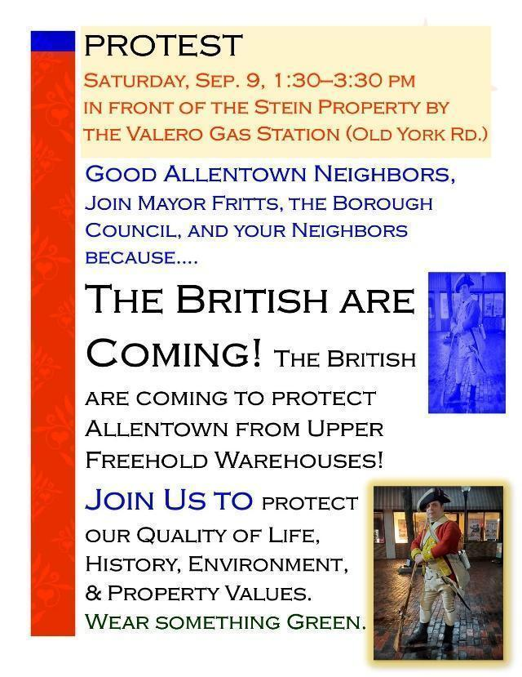
Figure 1 – The British Are Coming Protest Flier for September 9, 2023, to fight the proposed warehouses on Revolutionary War land. Written by Sue Kozel.

This article provides reflection on the role of a public historian in reorganizing turgid and overwhelmingly detailed facts in a manageable format for public consumption, including planning board members, the general public, legislators and other elected officials, and the media. The story of a community effort to fight the proposed placement of nearly 500,000 sq. ft. of warehouses on a British encampment site in Upper Freehold, New Jersey, tied to the retreat of the British from Philadelphia to New Jersey, continues to take many unexpected twists and turns. Founding Father and military strategist George Washington might be scratching his head if he were here, asking why, with America 250 rapidly approaching, would some local leaders want to destroy an important New Jersey American Revolutionary War site. The encampment, held on June 24, 1778, left the village of Allentown on June 25, joining with British troops in Imlaystown as they marched toward Monmouth Courthouse to what would become the Battle of Monmouth on June 28, 1778. One point of confusion focused on the Revolutionary War–era village of Allentown. At that time, Allentown was part of Upper Freehold Township. After Allentown separated from Upper Freehold in 1889, the Stein property became part of Upper Freehold Township.
Sometimes the battlegrounds to preserve Revolutionary War land take place in places and spaces such as newspapers and television, legislation, local planning boards, social media, American presidential archives, historical maps and journals, and emails with historic preservation ideas to county and state officials. The story to protect the roughly 60-acre parcel that housed a British encampment from warehouses and preserve a piece of significant Upper Freehold Revolutionary War history first caught the attention of New Jerseyans in a 2023 news article.
On June 12, 2023, many Monmouth County residents read an article by Gerry Carino in the Asbury Park Press reporting that almost 500,000 square feet of speculative warehouses would be developed on a June 25, 1778, British encampment site in Allentown, a part of Upper Freehold, New Jersey at that time. Based on his research, longstanding Allentown local historian John Fabiano joined with resident Rick Jakober and described how the Continental forces were very concerned about the British encampment and retreat from Philadelphia that took them into Western Monmouth County. Within the article was a representation of a map by Col. John André of the British encampment in Allentown (then part of Upper Freehold), and I wanted to know more about the source and Col. André and his map.
Col. André, an infamous British spy who was executed for collusion with American General Benedict Arnold, wrote a detailed diary following the British retreat from Philadelphia across New Jersey. His diary pages dedicated to Allentown and Upper Freehold included two maps, the aforementioned one and another tracking the British in other areas of Upper Freehold including the road to Monmouth (today Route 524) and Imlaystown, where a second division of Commander Clinton’s army was stationed on June 24, 1778, and left the next day.
The original map, as part of the André diary, is housed at the Huntington Digital Library. See Figure 2.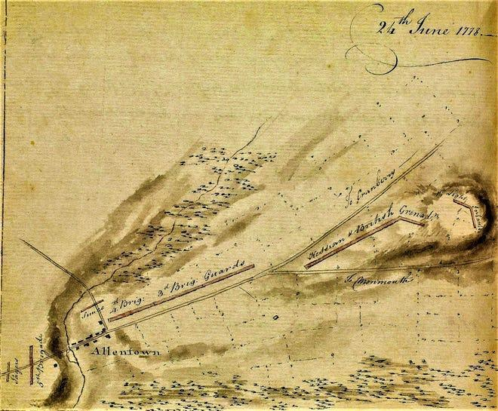
Figure 2 –The June 24, 1778, Col. John André’s Map of Allentown, which included troops marked in red and the split in Old York Road to take British General Henry Clinton’s troops to meet British Lt. Gen. William Knyphausen and his troops in Imlaystown on June 25, 1778. Used with permission from the Huntington Digital Library, San Marino, California.

The Allentown map of June 24, 1778, showed the British encampment stretched throughout Allentown and included the site that in 2023 was proposed for mega warehouses. The land, known previously as the Stein property, could secure $1.6 million in ratables for Upper Freehold staff, according to Upper Freehold Mayor Robert Frascella. Frascella did not provide evidence to support his claim. Rick Jakober, who was featured in Carino’s Asbury Park Press story, believed he could superimpose the image of the Andre map’s representation of British troops on a modern map of Upper Freehold.
At the July 27, 2023, Monmouth County Board of Commissioners meeting, Jakober unveiled his recreated map that he believed accurately mapped the site of British troops, and that site included the dubbed AAESUF Property, Inc. warehouses proposal land (See Figure 3). He, Tolani Taylor from Clean Water Action NJ, and Sue Kozel, public historian, presented facts about warehouse air pollution anticipated from the site, traffic concerns, and historical evidence about the site, including the presentation of the André map. Jakober’s overlay was correct, as evidenced by the developer’s expert witness testimony before the Upper Freehold Planning Board meeting on March 26, 2024, where he showed a slide that placed part of the British encampment on the AAESUF warehouse proposed land.
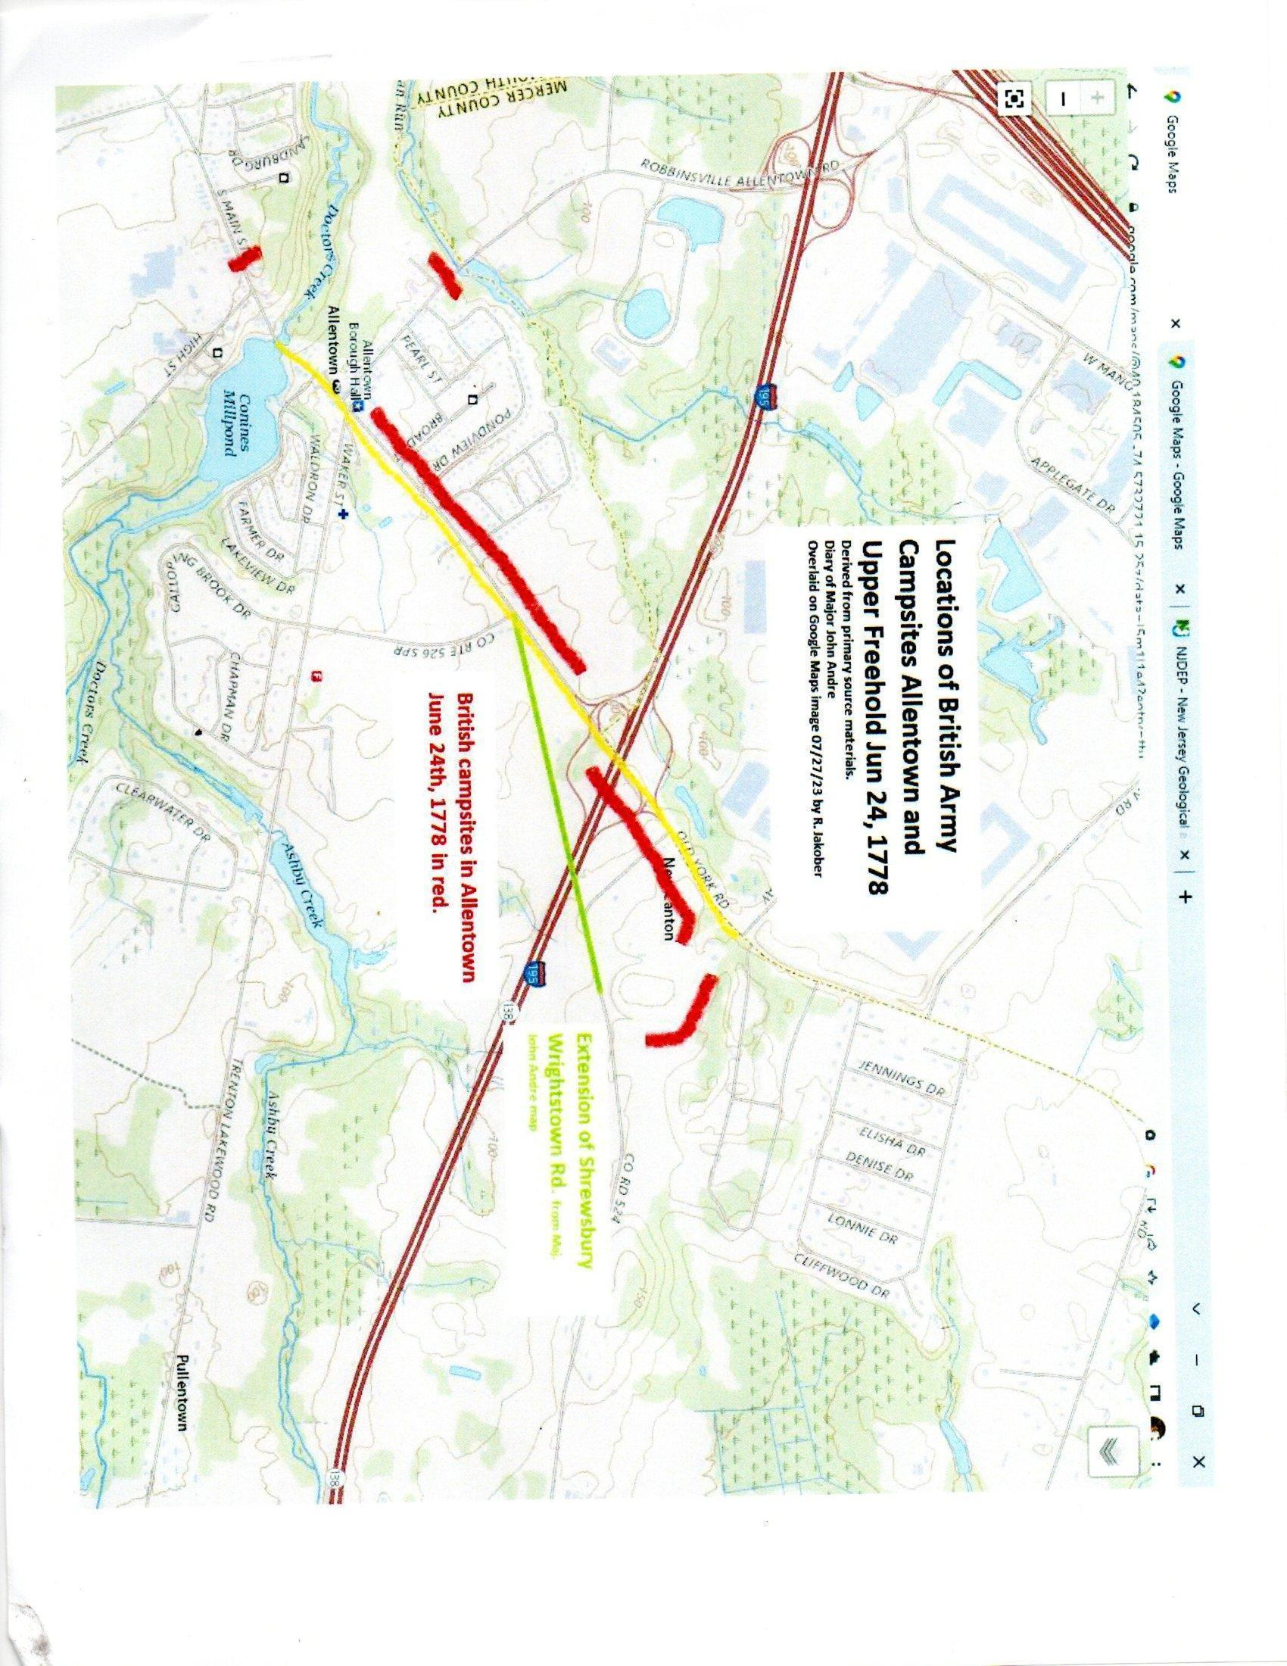
Figure 3 – Rick Jakober’s reconstruction of the June 24, 1778 British Encampment in Allentown, then Upper Freehold, NJ, and layered the historical troop settlement on a modern map. The layout indicated that the British Troops were indeed on the AAESUF proposed warehouse site.

When presenting at the New Jersey Historical Commission’s November 17, 2023, conference, I quoted Monmouth County Commissioner Ross Licitra on the need to preserve the British Encampment: “Public and private partnerships to preserve historical landmarks work. We in Monmouth County working hard to pull together the support and resources to see the British Encampment/Revolutionary War land in Upper Freehold protected as part of America 250.” His statement proved especially important because at the time of this publication, the Monmouth County Board of Recreation Commissioners and the AAESUF developer have been meeting to discuss the permanent preservation of the Revolutionary War land.
Licitra sent a clear and powerful message that reinforced the local leadership of Allentown Mayor Thomas Fritts and the Allentown Council and that people were prepared to fight for land preservation and protecting historical memory. Mayor Fritts said, “On behalf of Historical Allentown, our community has worked to preserve historic treasures and our past. The Stein/AAESUF property contains a British encampment in Allentown on what would become the road to the Battle of Monmouth. We support the efforts of Monmouth County to block warehouses from destroying our Revolutionary War history.”
Allentown resident John Tew organized a protest of Allentown and Upper Freehold neighbors on the right-of-way facing the AAESUF proposed warehouse land on Old York Road in Upper Freehold. Members of the press including the Asbury Park Press, Spotlight News, and later News 12 covered the protest and the aftermath in urging the Monmouth County Commissioners and the Monmouth County Board of Recreation Commissioners to negotiate with the developer to preserve the land. Assemblyman Alex Sauickie introduced A-5677 in 2023 to create a fund for grants to help communities facing warehouse and other development on Revolutionary War sites. To date the legislation has yet to move. The leadership in this preservation fight resembles a many-headed hydra of individuals often working independently to garner support for preservation. Over the year, the Society of the Cincinnati, the American Battlefield Trust, Crossroads of the American Revolution, the Monmouth County Sons of the American Revolution, New Jersey Sons of the American Revolution, and other prominent preservation organizations wrote letters to the Upper Freehold Planning Board in support of preservation for the British encampment. But the front-page Asbury Park Press story, which described the environmentally sensitive lands and wetlands threatened by stormwater challenges and the history of the British encampment, captured the public’s imagination and drew in the interest of elected officials.
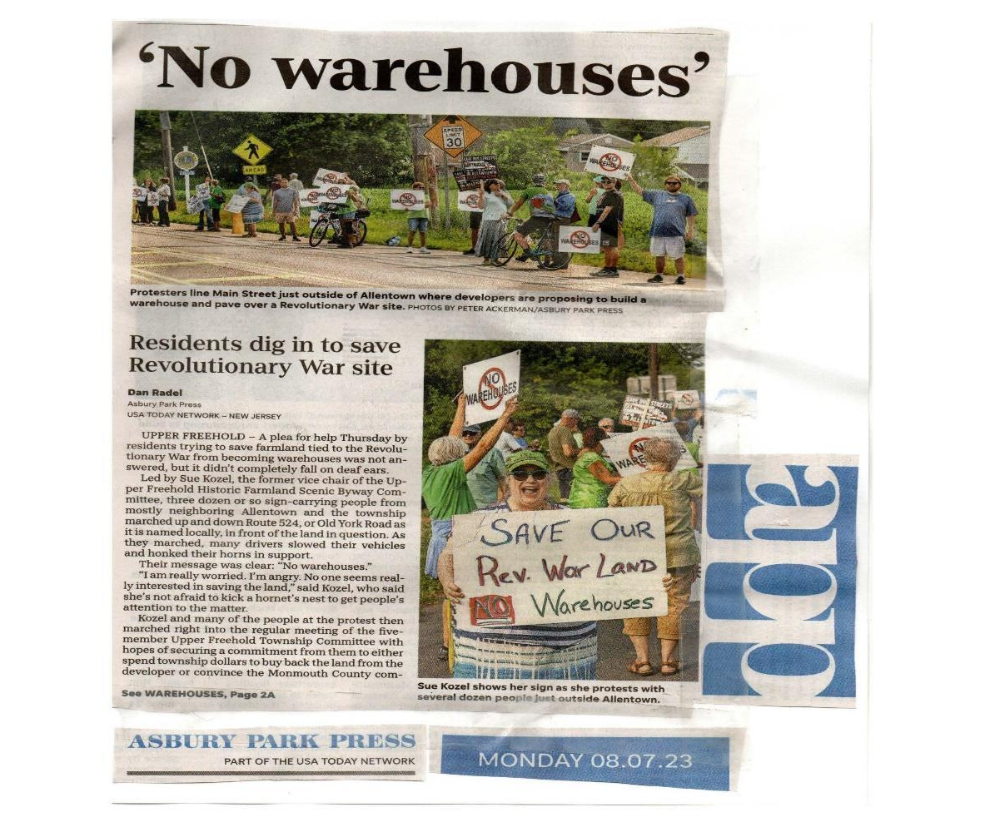
Figure 4 – Front Page Story by Dan Radel on Monday, August 7, 2023, in the Asbury Park Press

The focus on the AAESUF warehouses land quickly shifted to protecting the existing farmland and the site of land that once housed a Revolutionary War encampment and was reflected in anti-warehouse poster themes (See Figure 5).
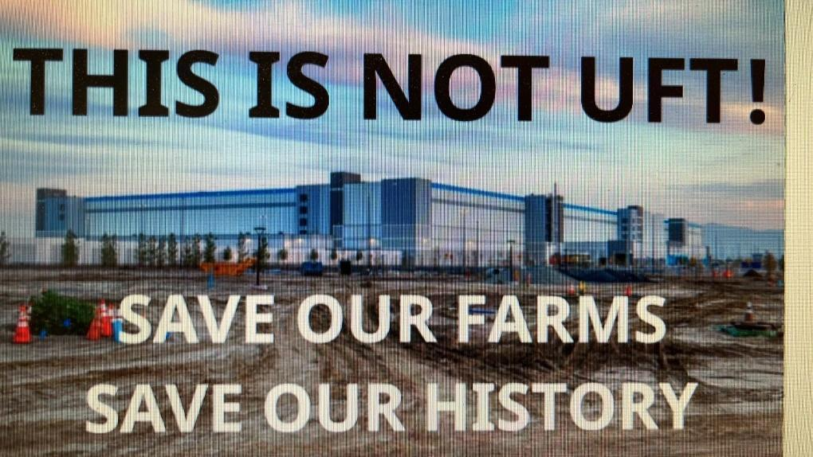
Figure 5 – One of the images used to promote historical and agricultural preservation.

The year 2024 directed new attention to the unregulated pollution associated with warehouses, including their related diesel truck traffic. On June 18, a group of anti-warehouse activists, including the author, participated in a national press conference organized by Clean Water Action NJ’s Tolani Taylor and the Environmental Defense Fund (EDF). EDF released on June 18, 2024, a new research report entitled, New Jersey Warehouse Boom. The report highlighted that one in three New Jersey residents live within half a mile of warehouses, a total of 2.7 million New Jerseyans. New Jersey’s 3,034 warehouses generated at least “380,000 daily truck trips.” The report concluded that children who lived near these warehouses suffered from asthma caused by pollutants, and often these children are from communities of color. The report noted that NJ children of color living less than a half mile of warehouses, like children in other parts of the state are subject to “medium- and heavy-duty trucks and buses are equipped with diesel engines that release more NOx and PM2.5 compared with gasoline engines.” The author has worked with Taylor to help save the Revolutionary War land in Upper Freehold, and she discussed how new pollution will be brought to people living one hundred feet from the edge of the proposed new warehouses.
2024 also marked the beginning of Upper Freehold Planning Board meetings on the controversial application plan.
At the March 26, 2024, meeting, Upper Freehold Mayor Robert Frascella suggested that the André map might not be authentic due to the spelling of Allentown. The developer’s representative authenticated the map. During the same meeting, Upper Freehold Committeeman Steve Alexander questioned the same AAESUF expert on archaeology, asking for background on André. Speaking for the developer, archaeologist Matt Tomaso said he did not know, and Alexander informed him he was a traitor that was hung. This point may seem trivial, but there has been an attempt in social media and publicly by Upper Freehold leaders to suggest that the preservation of a British Encampment was an unpatriotic idea during the American 250 period.
George Washington and Warehouses
In response to this argument, the author conducted a rapid-fire review of the Founder’s Online archive materials, the George Washington Papers, and the Library of Congress and identified any letters or directives to and from General George Washington or his generals in the Battle of Monmouth campaign. Searching references to “Allentown,” “Allen Town,” “Allen’s Town,” “allen town,” or other spelling variations of the name Allentown helped hone in key findings. Additionally, the search was designed to answer the historical puzzle of significance and determine how important the Allentown British encampment was on the American military’s radar. Drawing from Mark Edward Lender and Garry Wheeler Stone’s Fatal Sunday: George Washington, the Monmouth Campaign and the Politics of Battle as the seminal guide to help interpret the primary documents, their evidence highlighted that the British encampment aggravated the Americans and there were rapid responses with troop movements trying to intercept the British in Allentown, then a part of Upper Freehold. This research was presented as my sworn history witness testimony on behalf of Allentown, entitled “Founder’s Online and Other Historic Sources/Primary Documents: The Important of Allentown and Upper Freehold to the British and American Military Official Regarding the AAESUF/Upper Freehold British Encampment on June 24 1778, leaving June 25, 1778.”
Among the nearly twenty letters that focus American attention on the British arrival to and retreat from Allentown, the earliest letter is dated June 23, 1778. Major General Philemon Dickinson sent a letter to General George Washington indicating that the British were expected to arrive soon in Allentown. “From every present appearance, I believe the Enemy intend their rout thro’ allentown—...”
On the same day, Charles Stewart wrote a letter to General George Washington dated 23 June 1778 describing the skirmish of the British and Americans as the British left Crosswicks, in Burlington County, that day. Another source reported on this battle. As the British moved through Crosswicks on the way to Allentown, Sir Henry Clinton prepared for attacks along Crosswicks Creek in Upper Freehold. Colin Zimmerman, in the Journal of the American Republic, wrote: “The stage was set for the fight along Crosswicks Creek. Clinton intended to send the vanguard and Cornwallis over the bridge spanning Crosswicks Creek and then move northeast towards Allentown, all the while shielding Knyphausen and hoping to find Washington’s army and perhaps destroy it.”
Also on June 23, 1778, correspondence from Col. Stephen Moylan to General George Washington outlined how Moylan felt the British were in Allentown that day. We know that Moylan was wrong—the British would arrive on June 24, 1778—but the letter demonstrated how important Allentown became for the American military as a place to confront the British. “General Reed was down with me, in view of the enemy he can therefore inform you of every thing material, I have orderd Colonel White with a Squadron of Horse, into the Rear of the enemy, whose van I believe to be at this time in Allentown…”
Given the importance of the British military movement, one should not be surprised that General Washington held a strategic planning and operations meeting on June 24, 1778, as the British were sending one of two flanks marching into Allentown to create a base camp. The Americans held a special war council meeting that day. General Washington and his military leaders focused on the British encampment in Allentown and the British troop movement. The note opens with this intelligence, “His Excellency informs the Council, that by the latest advices, he has received, the Enemy are in two columns, one on the Allen Town and the other on the Borden Town road, The front of the latter near the Drawbridge, at which the Two roads unite in the main Cranbury road; Their force from the best estimate he can form is between 9 & 10,000 rank & file.” For example, in the orders, this directive was given: “A detachment of fifteen hundred men to be immediately sent to act as occasion may serve, on the enemy’s left flank and rear, in conjunction with the other Continental troops and militia, which are already hanging about them.” This council of war document also noted “that in addition to this force, from the amount given by Genl Dickinson there appear to be about 1200 Militia, collected in the Neighbourhood of the Enemy, who in conjunction with General Maxwell are hovering on their flanks & rear and obstructing their march.”
The war council meeting demonstrated that the Americans had become obsessed with the British troop movement, including in Allentown, dedicating orders for the “obstructing” of the British movement. Earlier in the day of June 24th, General Washington sent orders to “harrass the enemy” to Brigadier General Charles Scott. Critics of the preservation argued that the community supporting preservation were insulting the memory of Americans killed by the British, but the historical documents demonstrated the opposite. General Washington and his leadership team focused on the importance of the British encampment and dedicated resources to try to intercept Clinton’s forces.
The historical puzzle was answered, and the importance of the British encampment in Allentown to the American forces was again reinforced in the “General Orders” dated 24 June 1778, when American officers were directed not to leave their encampments and be ready for new troop movement. In the letter’s explanatory note, George Washington’s aide James McHenry referred to Allentown in his journal, “In consequence of intelligence from Gen. Dickinson we remain on the ground we took possession of yesterday—The day spent in digesting intelligence, & in decyphering the Enemys intentions. … The seventh day since the evacuation of Philada & the Enemy but near Allens Town. this gives rise to a conjecture that their delay is not the consequence of obstructions, broken Bridges &c. but that it proceeds from a desire of giving us Battle. I don’t think so”…”
In the James McHenry text of his personal journal, the text noted in a Founder’s Online aforementioned explanatory note is confirmed. Furthermore, McHenry noted that on June 24th, “1400 picked men ordered to march towards the enemy under Brigadier General Scott.” On June 23rd, McHenry noted that “600 men detached under Col. Morgan to hang on the enemy in conjunction with the militia.” On June 25th, the Marquis de Lafayette was sent to support Brigadier General Scott’s effort the day. Lender and Stone, in Fatal Sunday, noted that Lafayette moved from Kingston on June 25th to arrive in Cranbury that evening, suggesting that Lafayette’s troops did not meet up with Scott around Allentown. Lender and Stone reported that General Henry Clinton’s army had orders to leave Allentown at 4 a.m. on June 25 with a reversal of orders with the baggage train moving to the front of the army. Lender and Stone, however, later qualified their comment on what was the actual time the British departed Allentown, commenting that “The 1st Division was slow to depart Allentown.” On the same point, Lender and Stone wrote, “The rearrangement took time, and by the time the jaegers were clear of the village, a ‘body’ of the enemy had advanced through the streets toward the Hessians . . . A shot or two from their 3-pounders’ dispersed these rebels.” This sentence proved interesting because it suggested the good people of Allentown and/or the American military ran through the streets of Allentown toward the German mercenaries. One attempted skirmish by “rebels” with the British occurred at Robert Montgomery’s house, which would be marked on roads as Route 524 in Upper Freehold today. Note that the British encampment in Allentown moved toward Imlaystown to join the other British column on June 25th and most likely passed the Montgomery house.
Living in a digital and internet world where individuals can send notices within seconds to their intended audiences, one marvels at the flurry of issuance and delivery of American intelligence and order communiques in 1774. The Americans had valuable information on the separation of the Clinton army into two flanks and the way the divisions were moving, as evidenced below. The Continentals were able to pass significant correspondence back and forth, but not always could the actions listed in the letters be followed. A letter to General George Washington from Major Jacob Morris, dated 24 June 1778, discussed an attack on the Crosswick’s Bridge, Wall’s Mill (Waln’s Mill, part of Walnford in Upper Freehold), and Wriggle’s Town, what the explanatory note explained as “Recklesstown,” also known as Chesterfield, Burlington County. “Coll White sent off an officer early in the morning to reconnoitre the rear of the enemy between Wriggles Town, & Wall’s Mills, who informed him that a strong Column were marching on that road towards Imlay Town.
From the accts recd per Deserters & what the Inhabitants say, the Column upon the right to proceed by way of Walls Mills, & that on the Left by way of allentown, seperated at wriggles town from each other & are to form a junction at Imlay town this evening.”
A letter to General George Washington from Colonel Henry Jackson on June 24, 1778, discussed the attack on the separation of the British into two flanks, one toward Allentown and one toward Walls Mill (Waln’s Mill, part of Walnford, Upper Freehold). “Follow the Route of the Enimy—Their Rear move’d about 9 O.C. this Morg from Rechleys Town— they march’d in two divisions. the right towards Walls Mill & the Left towards Allen Town—I have in my detachments 240 Men—Colo. White is here with about 50 Light Dragoons—about two Miles in my front is 3 Companys of Continental Soldiers—these are all the Troops that are in their Rear—…”
General George Washington received a letter from Major General Steuben, dated 25 June 1778, that reported on the British in “Allens town” and “Imlays town”: “I arrived here this morning and found Genl Scott waiting intelligence, which has since arrived that the Enemy lay last night in two Columns one at Allens Town the other at Imlays Town, this morning about Eight oClock the Column from Imlays Town moved & took the Road to Monmouth Court House, we have not yet received any intelligence of the Column at Allens Town—…”
General George Washington received a letter from Col Daniel Morgan on June 25, 1778, in which he tracked the British along “crosswick Creek, “and the road as “far as allen town.” Morgan could not engage until he crossed the creek. He noted that “some part of them,” the British, encamped in Allentown June 24th. The Crosswicks Creek is the heart of the modern watershed that includes the said creek, Indian Run, and Doctor’s Creek as key waterways. Morgan was unable to intercept the actual encampment until he crossed the creek, and it remains unclear if he was referring to the actual Crosswicks Creek or another ancillary waterway given the description of his having to leave Allentown to cross the waterway.
A letter to General George Washington from Brigadier General William Maxwell, dated 25 June 1778, discussed the British retreat from Allentown and the extreme heat that day. Additionally, Major Bloomfield was mentioned as noting that cattle from the wagons were loose on the road and their deserters found by the Americans, due to the heat. Lender and Stone described this wagon train with five thousand horses and fifteen hundred wagons when assembled in Philadelphia. We do not know how many horses or individual troops perished on this day for their side.
Black History and Warehouses
African American noncombatants were part of the British wagon train that helped organize the massive group of British troops, their belongings, livestock, and the like under Clinton’s leadership. We must consider that when the British wagons broke down or a bridge or road needed repairing, it was most likely the African American Pioneers, who worked in the 2nd Division of Crown Forces under the command of Lt. General William Knyphausen, who fixed these problems. Fatal Sunday discussed that the Black Pioneers under Knyphausen were among the 9,153 men, women, and children that were part of his 2nd Division, under Clinton. A total of forty-nine men and two women who served in the Black Pioneers noncombatant group were part of the total. The work of Todd Braisted underscores the significance of the Black Pioneers as Loyalist noncombatants whose contributions proved vital to the operations of the British Army.
Richard S. Walling published a seminal work on African American and Native American soldiers at the Battle of Monmouth. Walling noted that the British Black Pioneers also repaired bridges destroyed by the Americans trying to delay Clinton’s movement through New Jersey. African Americans who served with the British moved with the baggage wagon and removed debris. Did any of the British Black Pioneers march through Allentown, repairing bridges or roads that were sabotaged by the Continentals or New Jersey troops? Did any of these men and women get rerouted and march through Allentown? Were these British subjects seen by the enslaved men, women, and children in Allentown and Upper Freehold? Imagine for a moment what enslavers and enslaved people might have thought seeing men wearing the “Liberty to Slaves” shirts first worn by Lord Dunmore’s Ethiopian Brigade. We do not know for certain, because scholars like historian Todd Braisted believed that the Black Pioneers were part of General Wilhelm Von Knyphausen’s division that marched from Crosswicks to Imlaystown, not Allentown. Further research needs to confirm exactly where the noncombatant free Blacks marched.
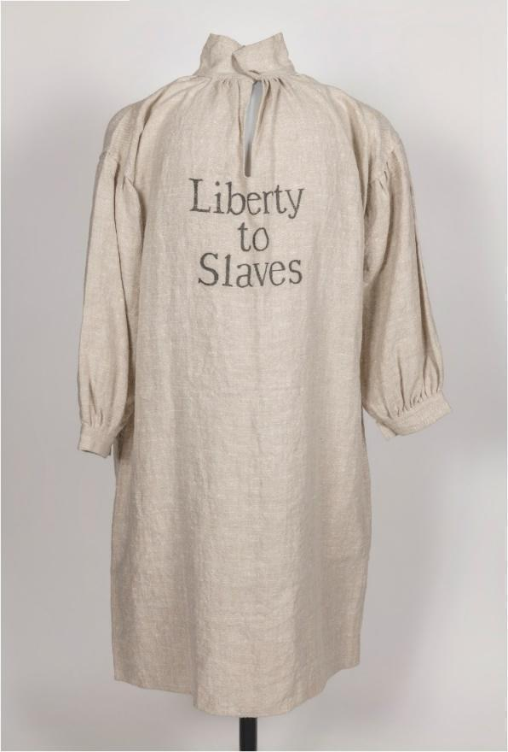
See Figure 6.

Figure 6 – “Liberty to Slaves” image (NA 0002_v1.jpg), Virginia Museum of History & Culture, Virginia Historical Society. Permission granted to use this image, courtesy of Virginia Museum of History & Culture.
According to Fatal Sunday, another group of African Americans, the Black Brigade, played a role in Monmouth County with “hit-and-run forays against coastal communities.”⁸ While many teaching resources and scholars have written about how the famous Monmouth County Colonel Tye from Shrewsbury, a runaway enslaved man, led British attacks against numerous shore-area communities, Graham Russell Hodges has reported on his role as a revolutionary Black privateer who challenged the Continentals and Monmouth County residents after his self-emancipation from enslavement in Monmouth County. In his effort to capture American military leader Joshua Huddy, Tye was wounded and died. ⁹ Colonel Tye’s story is powerful and well documented in Eastern Monmouth as a privateer and guerilla war fighter, with much credit to be given to another former recipient of a New Jersey Historical Commission award, Graham Russell Hodges Gao, as an authority on Tye’s leadership. Tye appears to not have made his way out to greater Allentown. But his story stands as a tribute to the leadership of African American fighters on both sides of the Revolutionary War. With this preservation of the British encampment, we will be able to investigate and document new stories of Black history in Western Monmouth. But we have some insights on Black lives in Upper Freehold at the time of the British encampment.
Tax ratables provided important insights into African American enslavement during the Revolutionary War and the early American Republic eras. By focusing on three years of financial data, a profile of enslavement and free Black landowners in Upper Freehold emerged. In May–June 1778, seventy African American men and older boys were counted as enslaved for tax purposes in Upper Freehold, which included Allentown. The true number of enslaved was higher and sadly unknown because women, the elderly, and children were not included in the tax ratable count. Upper Freehold did not record the number of free Blacks by surname or number on the 1778 tax ratables list. In subsequent years, free Blacks were listed separately as “Free Negroes,” “Negroes,”or sometimes inserted into the lists of white property owners. One example is “Black Mingo a negro” being listed as a property owner in the Upper Freehold July 1780 records and registered under the “Single Men” category.
By the year 1789, a change transformed the profile of African American presence in Upper Freehold. While a free nation for white Americans emerged, not all African Americans were freed. What is significant on the Upper Freehold tax ratable list is that seventeen African American men were listed as “Free Negroes” who owned 274 acres of land, while fifty-three males were owned by Upper Freehold (including Allentown at that time) white men. Enslavers’ names included but are not limited to: Barkelow, Imlay, Lawrence, Mount, Newell, Polhemus, and Wikoff. Some of these families lived along or near what now is the twenty-four mile Upper Freehold Historic Farmland Scenic Byway that runs through parts of Allentown and Upper Freehold. Note spellings of surnames are not always consistent in this time period.
The free Black names for 1789 sometimes include surnames: Ceafar, Bill Anderfon’s, Jim Anderfons, Mingo, Tom Cavey, Ned Coward’s, Charles Green, Darius Wooby, Tom South, Ephraim Rwaley, Garret Pott’s, Cato Pott’s, Isaac Green, George Coal, George, Sam Apollo Woodwards, and Sam Jos. Lawrence. Jim Anderfons owned twenty-four acres of improved land, Tom Cavey owned seventy-five acres of improved land, Ephraim Rowley owned seventy-five acres of improved land, and Sam Jos. Lawrence owned one hundred acres of land, so African American men owned a total of 274 acres of land in Upper Freehold in 1789.
New Jersey’s enslaved men, women, and children were part of the 11,423 enslaved people living in New Jersey in 1790. Upper Freehold was and remains today bordered by Provinceline Road, the road that separated East from West Jersey. Enslaved people were forced to live in the East Jersey community of Upper Freehold, Monmouth County, and were counted nameless in the 1790 census. When the three-fifths rule was enacted, those boys and men ages 12–50 were taxed (with the tax paid by their enslavers) in the first 1798 Direct Tax. For Upper Freehold, the 1790 census noted that 250 enslaved people lived there along with 108 free Blacks.

Table: Upper Freehold 1790 published census information
Category | Total
Free white males of 16 years and upwards, including heads of families | 763
Free white males under 16 years of age | 789
Free white females including heads of households | 1532
All other free persons | 108
Slaves | 250
Total number in Upper Freehold | 3442
Total number in Monmouth County | 16,981

Figure 7. Monmouth County Citizen and Enslaved Numbers, 1790
US Bureau of the Census. “Return of the Whole Number of Persons Within the Several Districts of the United States, According to ‘An Act Providing for the Enumeration of the Inhabitants of the United States;’ Passed March the First, One Thousand Seven Hundred and Ninety-One. [i.e. 1790]” #54 - Return of the whole number of persons within the several districts ... - Full View | HathiTrust Digital Library
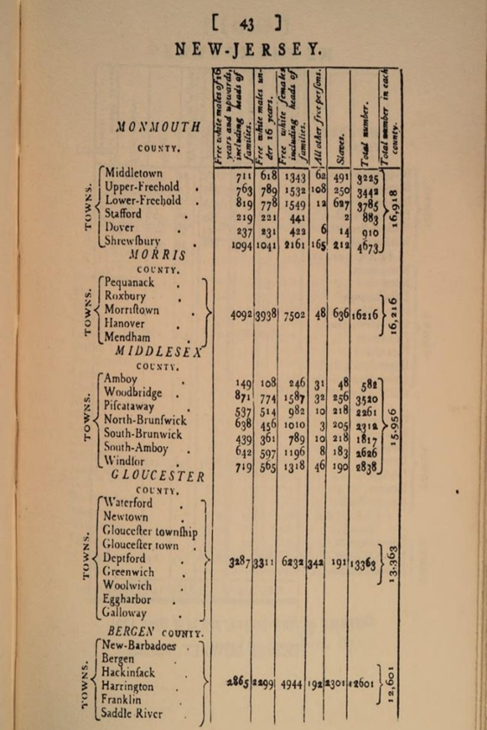

With the significant increase in recorded enslaved people listed for Upper Freehold in the 1790 federal census, the Upper Freehold tax ratables were not available for 1790 for which to compare numbers. However, the trend in tax ratable returns in three years highlighted lower enslavement numbers for the township. In 1792, a total of fifty-one men and older boys were listed as enslaved, although the number of free Blacks owning land and paying taxes grew to twenty-five. Again, enslaved women, girls, young children, and elderly men and women were excluded from being counted in the tax rolls (with the exception of when total slave population census numbers were required like in 1784). The number of acres owned by free Black men equaled 359 acres, which increased from the 1789 tax ratables list. These numbers represent human beings who may have witnessed the British army invasion of their communities and the representation of African American combatant and noncombatant soldiers for the British and Americans as they clashed in the vicinity of Allentown.
Over eight hundred Black men fought at the Battle of Monmouth. The work of Richard Walling greatly enhanced historical knowledge of the accomplishments of African American soldiers to the Revolutionary War effort.
New Jersey free Black William Stives, an African American patriot, fought in the Battle of Monmouth and joined the American forces in attacking the British while they moved through Crosswicks, in Burlington County, on their way to Allentown on June 24, 1778. Walling did not list Stives as one of the African American men in his writing on the Battle of Monmouth. His New Jersey pension papers indicated that Stives served under Captain Richard Cox in Colonel Barber’s unit. A member of the Third New Jersey Regiment, led by Col. Elias Dayton during the Battle of Monmouth on June 28, 1778, Private Stives was a fifer and also served in Valley Forge with General George Washington. Much of Stives story as a free Black man has been featured in the wonderful book by Elaine Buck and Beverly Mills, If These Stones Could Talk: African American Presence in the Hopewell Valley, Sourland Mountain, and Surrounding Regions of New Jersey. He may have been involved in the skirmishes in or near Allentown and Upper Freehold Township because he was engaged in the Crosswicks skirmishes.
Richard S. Walling described the contributions of Oliver Cromwell, a Burlington County African American who fought in the Battle of Monmouth. We do not know if Cromwell participated in any skirmishes in Allentown and Upper Freehold.
As part of America 250, New Jersey community history that presents mostly a narrow history of white freedom needs to further explore the African American presence on both sides of the war in their local history in addition to the role of Native American soldiers. One year after the Battle of Monmouth, Maxwell’s Brigade turned to fighting Native Americans during the stages of the American Revolution that fought the British in the “west.” These important diverse histories should further expand upon and guide how we present the story of the British encampment in Upper Freehold in maps, narratives, heritage signage, and programming. But the first step is for Monmouth County to act and preserve the British encampment and save it from speculative warehouse destruction. The documented historical evidence exists to justify preserving this Revolutionary War land. Then, with county support, local history projects can begin to further research the history and document all people, free and unfree, who engaged in this Revolutionary moment.
The Battle of Monmouth 2.0 in Upper Freehold continues in the name of honoring Revolutionary War history. The Upper Freehold Township planning board meetings concluded, a lawsuit was announced, legislation was introduced to address warehouses encroaching on historic designated districts, the Governor’s staff considered a partnership with the Monmouth County Commissioners, two Gubernatorial candidates (Fulop and Durr) supported preservation of this Upper Freehold land, and the people of Allentown and Upper Freehold remain resolved to fight for preservation from mega warehouses. For anyone suggesting that history has no role to play in modern politics, the Upper Freehold warehouse battle over preserving a Revolutionary War site disproved that idea. History does drive public policy discussions of historic memory, land preservation, and the choices local, county, and state governments, with their residents, make about the meaning of their lives.

Sue Kozel happily retired twice: from her business and the second time from thirteen and one-half years of teaching at various New Jersey community colleges and two state universities. After her husband, her first love is historical research. She will be presenting her New Jersey Council for the Humanities research on the early Black history of Woodbury as part of the conference, Teaching Revolutionary New Jersey, to be held at Atlantic-Cape Community College on May 23, 2025. She has served as a Fellow with the International Center for Jefferson Studies and has been the recipient of two grants from the New Jersey Historical Commission to research slavery and freedom in Western Monmouth County. Sue has lectured about Quaker abolitionists in Europe and the United States and is best known for her writing and presenting on “The Murder of Wench Betty,” an enslaved Monmouth County woman murdered by her enslaver, a Revolutionary War veteran. She is honored to be a member of the Allentown 250 Committee and recently joined The Allentown Village Initiative (TAVI) 250 Committee. In 2024–2025, she donated forty-five history texts to the New Jersey State Library and another 142 books to the Allentown Public Library to help promote history reading. You can find Sue on Meta, LinkedIn, X, and Bluesky.

Rick Condon, “What is Public History,” The Civil War Monitor, April 29, 2024, https://www.civilwarmonitor.com/what-is-public-history/. See also, “How Do We Define Public History?” National Council on Public History, https://ncph.org/what-is-public-history/about-the-field/.
“250 Anniversary/Revolutionary News,” Crossroads of the American Revolution https://revolutionarynj.org/category/250-anniversaryrevolutionary-news/. “New Jersey’s Commemoration of America’s 250th,” RevolutionNJ, https://www.revnj.org. The RevolutionNJ Handbook can also be found and downloaded at this site, https://www.revnj.org/resources.
Olivia Liu, “Allentown sues in bid to stop controversial warehouse,” Asbury Park Press, May 12, 2025. Olivia Liu, “Shame!: Upper Freehold Oks Warehouses after 10-month hearing, but Allentown will fight,” Asbury Park Press, December 19, 2024, https://www.yahoo.com/news/shame-upper-freehold-oks-warehouses-101231161.html. Sue Kozel yelled “shame” after the vote and described the continuing preservation efforts in the story. Ted Goldberg, “UFT faces possible lawsuit,” NJ Spotlight News, December 27, 2024, https://www.njspotlightnews.org/video/upper-freehold-warehouse-faces-possible-lawsuit/.
Note to reader: All historical text quoted from letters are in original form.
Gerry Carino, “‘Kick in the stomach.’ Warehouses on site of Revolutionary War fight? Allentown’s aghast,” June 12, 2023, https://www.app.com/story/news/history/2023/06/12/warehouses-site-revolutionary-war-fight-allentown-run-creek-rick-jakober/70301572007/.
“John André,” The Digital Encyclopedia of George Washington, The Washington Library, Mount Vernon, https://www.mountvernon.org/library/digitalhistory/digital-encyclopedia/article/john-andre/#:~:text=John%20Andr%C3%A9%20was%20born%20in,British%20commander%2Din%2Dchief.
The Map of the British Encampment in Allentown, a part of Upper Freehold, NJ. Journal of John André. HM 626. June 24, 1778. The Huntington Library, San Marino, CA., Page 228, Fol. 75br. https://hdl.huntington.org/digital/collection/p15150coll7/id/22416. Image permission secured by Sue Kozel with the Huntington Digital Library, San Marino, CA. High Resolution Copy.
See this text for important insights as to the Battle of Monmouth and some of the facts from the Allentown movement of British troops, and the attempt of the American forces to provide skirmishes with the British. Page 153 discussed troop movements from Allentown to Imlaystown. Mark Edward Lender and Garry Wheeler Stone, Fatal Sunday: George Washington, the Monmouth Campaign, and the Politics of Battle (OK: University of Oklahoma Press, 2016), 153.
The Map of the British Encampment in Allentown, a part of Upper Freehold, NJ. Journal of John André. HM 626. June 24, 1778. The Huntington Library, San Marino, CA., Page 227, Fol. 75av. https://hdl.huntington.org/digital/collection/p15150coll7/id/22415. Image permission secured by Sue Kozel with the Huntington Digital Library, San Marino, CA. High Resolution Copy. The quote attributed to Mayor Frascella was made during a July 12, 2023, phone conversation between Sue Kozel and the Mayor, documented in a running list of statements the Mayor made to support the AAESUF warehouse development. The Mayor serves both on the UFT Township Committee and the UFT Planning Board that will vote on the controversial warehouse application. Kozel served as a sworn history witness representing Allentown at the UFT Planning Board on June 4, 2024, and June 13, 2024, testifying under oath about statements made by members of the Township Committee who also serve on the Planning Board that constituted bias in favor of the warehouse project and the role of George Washington’s military orders related to the Upper Freehold property.
Sue Kozel, “The Battle of Monmouth 2.0 2023: The Fight to Save Upper Freehold Revolutionary War Land from Warehouses,” Unfinished Revolution, New Jersey Historical Commission Conference, November 17, 2023, Slide 17.
Kozel, “The Battle of Monmouth 2.0 2023: The Fight to Save Upper Freehold Revolutionary War Land from Warehouses,” Slide 17.
Some of the articles include Dan Radel, “No Warehouses: Residents Dig In to Save Revolutionary War Site,” Asbury Park Press, August 7, 2024, A1-A2. Jon Hurdle, “Monmouth County seeks to stop warehouses plan for Revolutionary War site, “ New Jersey Spotlight News, August 16, 2023, https://www.njspotlightnews.org/2023/08/monmouth-county-nj-wants-to-stop-warehouses-planned-for-revolutionary-war-site/. Ted Goldberg, “Upper Freehold Residents Protest Impact of warehouse sprawl on landmarks, environment,” New Jersey Spotlight News, August 4, 2023, https://www.njspotlightnews.org/video/upper-freehold-residents-protest-impact-of-warehouse-sprawl-on-landmarks-environment/. Dustin Racioppi, “A Private Matter for a Public Servant,” Politico, August 17, 2023. Jon Hurdle, New front opening in battles against warehouse sprawl,” New Jersey Spotlight News, August 8, 2023, https://www.njspotlightnews.org/2023/08/revolutionary-war-battlefield-rep-alex-sauickie-monmouth-county-development-review-committee-upper-freehold-allentown-monmouth-county-dep-inland-flood-protection-rule-association-of-new-jersey-enviro/. Brian Donohue, “Positively New Jersey: Monmouth County community fights latest warehouse site,” News 12, August 14, 2023, https://newjersey.news12.com/positively-new-jersey-monmouth-county-community-fights-latest-warehouse-site. Jackie Roman, “Don’t turn Revolutionary War Site into more New Jersey Warehouses, critics say,” NJ.com, June 10, 2024, https://www.nj.com/monmouth/2024/06/dont-turn-revolutionary-war-site-into-more-nj-warehouses-critics-say.html. Olivia Liu, “Bias claims, Revolutionary War history, protected birds,: Public gets say on warehouse plan,” Asbury Park Press, June 17, 2024 online, , https://www.app.com/story/news/local/redevelopment/2024/06/17/upper-freehold-warehouse-plan-to-go-before-the-public/74098036007/. Olivia Liu, “Allegations Aim to Stop Warehouses: Claims of bias, danger to history, and birds made by opponents,” Asbury Park Press, June 18, 2024, A- and A-9.
Assemblyman Alex Sauickie, A-5677, Warehouses and Development Issues, https://assemblymanalex.com/warehouses/.
Sam Becker, New Jersey Warehouse Boom: tracing the growth of warehouses and their impacts, Environmental Defense Fund (Washington, DC: Environmental Defense Fund, 2024), 2, 4, 5, 6, 9, 10, and 11. Derek Schwabe, “New Report Finds Roughly 1 in 3 New Jersey Residents Lives Near a Mega Warehouse,” June 18, 2024, https://www.edf.org/media/new-report-finds-roughly-one-three-new-jersey-residents-lives-near-mega-warehouse. The author of this article spoke at the press conference. P. Kenneth Burns, “Air pollution from New Jersey’s warehouse boom disproportionally impacts community of color, report finds,” WHYY.org, June 20, 2024, https://whyy.org/articles/new-jersey-warehouses-air-pollution-communities-of-color/.
Becker, New Jersey Warehouse Boom: tracing the growth of warehouses and their impacts, Environmental Defense Fund, 4.
Olivia Liu, “Radar, Shovels Needed to study Revolutionary War camp at proposed Monmouth warehouse,” Asbury Park Press, April 26, 2024, https://www.app.com/story/news/local/redevelopment/2024/04/25/revolutionary-war-camp-upper-freehold-warehouse-site-battle-monmouth/73437000007/
Please note that the original spelling of text, not consistent with modern language, will be used throughout this section of letters addressed to and from Washington, including war orders.
Lender and Stone, Fatal Sunday: George Washington, the Monmouth Campaign, and the Politics of Battle, 152–151-155. See chapter 6 for a full contextual description of troop leaders and movement.
Sue Kozel, Sworn History Witness, “Founder’s Online and Other Historic Sources/Primary Documents: The Important of Allentown and Upper Freehold to the British and American Military Official Regarding the AAESUF/Upper Freehold British Encampment on June 24 1778, leaving June 25, 1778,” June 13, 2024, unpublished report submitted to the Upper Freehold Planning Board.
“To George Washington from Major General Philemon Dickinson, 23 June 1778,” Founders Online, National Archives, https://founders.archives.gov/documents/Washington/03-15-02-0532. [Original source: The Papers of George Washington, Revolutionary War Series, vol. 15, May–June 1778, ed. Edward G. Lengel. (Charlottesville: University of Virginia Press, 2006), 512–513.]
“To George Washington from Charles Stewart, 23 June 1778,” Founders Online, National Archives, https://founders.archives.gov/documents/Washington/03-15-02-0541. [Original source: The Papers of George Washington, Revolutionary War Series, vol. 15, May–June 1778, ed. Edward G. Lengel. (Charlottesville: University of Virginia Press, 2006), 518–519.] Colin Zimmerman, “The Battle of Crosswicks: Prelude to Monmouth,” The Journal of the American Revolution, August 4, 2022, https://allthingsliberty.com/2022/08/the-battle-of-crosswicks-prelude-to-monmouth/.
“To George Washington from Colonel Stephen Moylan, 23 June 1778,” Founders Online, National Archives, https://founders.archives.gov/documents/Washington/03-15-02-0540. [Original source: The Papers of George Washington, Revolutionary War Series, vol. 15, May–June 1778, ed. Edward G. Lengel (Charlottesville: University of Virginia Press, 2006), 518.]
“Council of War, 24 June 1778,” Founders Online, National Archives, [Original source: The Papers of George Washington, Revolutionary War Series, vol. 15, May–June 1778, ed. Edward G. Lengel (Charlottesville: University of Virginia Press, 2006), 520–522.]
“Council of War, 24 June 1778,” Founders Online, National Archives.
“George Washington to Brigadier General Charles Scott, 24 June 1778,” Founders Online, National Archives, https://founders.archives.gov/documents/Hamilton/01-01-02-0490. [Original source: The Papers of Alexander Hamilton, vol. 1, 1768–1778, ed. Harold C. Syrett (New York: Columbia University Press, 1961), 503.]
Excerpted editorial notation from “General Orders, 24 June 1778,” Founders Online, National Archives, https://founders. archives.gov/documents/Washington/03-15-02-0542. [Original source: The Papers of George Washington, Revolutionary War Series, vol. 15, May–June 1778, ed. Edward G. Lengel. Charlottesville: University of Virginia Press, 2006, pp. 519–520.] in The Papers of George Washington: May-June 1778, Volume 15, Washington, George. Edited by Edward G. Lengel. © 2006 by the Rector and Visitors of the University of Virginia. Reprinted by permission of the University of Virginia Press.
James McHenry, Journal of a march, a battle, and a waterfall : being the version elaborated by James McHenry from his diary of the year 1778, begun at Valley Forge, & containing accounts of the British, the Indians, and the Battle of Monmouth (Greenwich, Connecticut: private publisher, 1945), 4. Courtesy of John Fabiano.
McHenry, Journal of a march, a battle, and a waterfall : being the version elaborated by James McHenry from his diary of the year 1778, begun at Valley Forge, & containing accounts of the British, the Indians, and the Battle of Monmouth, 3.
Lender and Stone, Fatal Sunday: George Washington, the Monmouth Campaign, and the Politics of Battle, 178–179, 443.
Lender and Stone, Fatal Sunday: George Washington, the Monmouth Campaign, and the Politics of Battle, 153, 157–158.
Lender and Stone, Fatal Sunday: George Washington, the Monmouth Campaign, and the Politics of Battle, 154–155. Chapter 6, “The Roads to Monmouth I, Henry Clinton’s March,” presented an excellent summary of movements to Allentown by the British and American forces.
Lender and Stone, Fatal Sunday: George Washington, the Monmouth Campaign, and the Politics of Battle, 154–155. Chapter 6, “The Roads to Monmouth I, Henry Clinton’s March,” presented an excellent summary of movements to Allentown by the British and American forces.
Stone and Lender, Fatal Sunday: George Washington, the Monmouth Campaign, and the Politics of Battle,178-179.
“To George Washington from Major Jacob Morris, 24 June 1778,” Founders Online, National Archives, https://founders.archives.gov/documents/Washington/03-15-02-0560. [Original source: The Papers of George Washington, Revolutionary War Series, vol. 15, May–June 1778, ed. Edward G. Lengel (Charlottesville: University of Virginia Press, 2006), 532–533.] “History of Chesterfield Township,” Chesterfield Historical Society http://www.chesterfieldtwphistoricalsoc.org/historical-information.html.
“To George Washington from Colonel Henry Jackson, 24 June 1778,” Founders Online, National Archives, https://founders.archives.gov/documents/Washington/03-15-02-0554. [Original source: The Papers of George Washington, Revolutionary War Series, vol. 15, May–June 1778, ed. Edward G. Lengel (Charlottesville: University of Virginia Press, 2006),527–528.]
“To George Washington from Major General Steuben, 25 June 1778,” Founders Online, National Archives, https://founders.archives.gov/documents/Washington/03-15-02-0580. [Original source: The Papers of George Washington, Revolutionary War Series, vol. 15, May–June 1778, ed. Edward G. Lengel (Charlottesville: University of Virginia Press, 2006), 545–546.]
“To George Washington from Colonel Daniel Morgan, 25 June 1778,” Founders Online, National Archives, https://founders.archives.gov/documents/Washington/03-15-02-0577. [Original source: The Papers of George Washington, Revolutionary War Series, vol. 15, May–June 1778, ed. Edward G. Lengel (Charlottesville: University of Virginia Press, 2006), 543–544.]
“To George Washington from Brigadier General William Maxwell, 25 June 1778,” Founders Online, National Archives, https://founders.archives.gov/documents/Washington/03-15-02-0575. [Original source: The Papers of George Washington, Revolutionary War Series, vol. 15, May–June 1778, ed. Edward G. Lengel (Charlottesville: University of Virginia Press, 2006), 542–543.]
Lender and Stone, Fatal Sunday: George Washington, the Monmouth Campaign, and the Politics of Battle, 97, 98.
Lender and Stone, Fatal Sunday: George Washington, the Monmouth Campaign, and the Politics of Battle, 54, 97, 98, 126, 127, 133, 467. Braisted, Todd W., ”The Black Pioneers and Others: The Military Role of Black Loyalists in the American War for Independence,” in John W. Polis ed., Moving On: Black Loyalists in the Afro-Atlantic World (New York and London: Garland Publishing, Inc., 1999), 3–37. Braisted did not focus on the Battle of Monmouth in this piece.
Richard Walling, Men of Color at the Battle of Monmouth, June 28, 1778: The Role of African Americans and Native Americans at Monmouth: Containing a Brief History of These Men of Color and a Presentation of Nearly Two Hundred Names and Identifications (Hightstown, NJ: Longstreet House, 1994), 5.
Lender and Stone, Fatal Sunday: George Washington, the Monmouth Campaign, and the Politics of Battle, 467. “Liberty to Slaves” image (NA 0002_v1.jpg), Virginia Museum of History & Culture, Virginia Historical Society. Email to Sue Kozel from Andrew M. Foster August 16, 2023 granting permission to use the image. See also, Jason G. Storey, “Fighting for liberty in an unequal society: African American military service in the American Revolution and the path towards citizenship,” (Eastern Michigan University, Master’s Theses, 2016), 11, 52. Master’s Theses and Doctoral Dissertations. http://commons.emich.edu/theses/871871.
Email from Todd Braisted to Sue Kozel, August 8, 2023.
Graham Russell Hodges, Black New Jersey: 1664 to the Present Day, New Brunswick: Rutgers University Press, 2019), 38-40.
Paul Finkleman, editor-in-chief, Oxford Encyclopedia of African American History, 1619-1895: From the Colonial Period to Age of Frederick Douglass, 3 Volumes (USA: Oxford University Press, 2006), 1: 61, 1: 64,1: 66, 1:119, 1: 140,1: 2: 200, 1:297, 1:313, 1:314, and 2: 439. See entry by Graham Russell Hodges Gao, “Colonel Tye,” Oxford Encyclopedia of African American History, 1619-1895: From the Colonial Period to Age of Frederick Douglass, Volume 1 (USA: Oxford University Press, 2006), 313-314, Google eBook preview, https://books.google.com/books?id=cCMbE4KKlX4C&newbks=1&newbks_redir=0&vq=Tye&source=gbs_navlinks_s.
Duplicate Record, The Upper Freehold Tax Ratables for May—June 1778, #1181, Copy, New Jersey State Archives. Digitized. White Taxpayers called “Persons” and no free Blacks listed.
Duplicate Record, The Upper Freehold Tax Ratables for July 1780, #1182, Copy, New Jersey State Archives. Digitized, 11. In the August 1780 record, Mingo does not appear. In some subsequent years, white taxpayers called “Persons” and a free Black listed under the “Persons” category, as usually only listed persons of the white race.
Duplicate Record, The Upper Freehold Tax Ratables for 1789, #1190, Copy, Pages 2, 8, 9, 11, 12, and 16. New Jersey State Archives. Digitized. White taxpayers called “Persons” and free Blacks listed in a separate column.
Sue Kozel Collection, Upper Freehold Vanishing Vistas and Scenic Byway Collection, Monmouth County Archives. https://www.monmouthcountyclerk.com/archives/record-groups/special-collections/upper-freehold-vanishing-vistas-and-scenic-byway-collection/. This collection was established in 2024 when Kozel donated four boxes of maps, reports, primary documents, and notes to the Monmouth County Archives, part of the Monmouth County Clerk’s Office. The Byway represents 24-miles of auto tour driving to visit scenic, environmental, agricultural, and farmland in Upper Freehold and Allentown.
Duplicate Record, The Upper Freehold Tax Ratables for 1789, #1190, Copy, Page 17. Note the use of apostrophe punctuation, and that sometimes free Blacks with the same surname are listed differently, such as Anderfons.
Return of the whole number of persons within the several districts of the United States : according to “An act providing for the enumeration of the inhabitants of the United States,” passed March the first, one thousand seven hundred and ninety-one [i.e., 1790] (Philadelphia: Childs and Swaine, 1791), 42-44. Hathi Trust, October 16, 2022. https://babel.hathitrust.org/cgi/pt?id=inu.30000120169259&view=1up&seq=51&size=125. “Free and Slave Populations by State, Teaching American History, “https://teachingamericanhistory.org/resource/the-constitutional-convention-free-and-slave-populations-by-state-1790/.
For discussion of direct tax tied to the Three-Fifth Tax that applies to enslaved men ages 12 to 50, see “The Three-Fifths Compromise,” Digital History, Source, Gilder Lehrman Institute, 2021, accessed December 1, 2023, https://www.digitalhistory.uh.edu/disp_textbook.cfm?smtID=3&psid=163 . For a discussion of the direct tax enacted as part of the three-fifths compromise, see Joseph R. Fishkin and William E. Forbath, “Congress as the Broad Power to Tax,” National Constitution Center, accessed December 1, 2023, https://constitutioncenter.org/the-constitution/amendments/amendment-xvi/interpretations/139#congress-has-broad-power-to-tax-by-joseph-fishkin-and-william-forbath.
Return of the whole number of persons within the several districts of the United States: according to “An act providing for the enumeration of the inhabitants of the United States,” passed March the first, one thousand seven hundred and ninety-one, 43. Note that Charles Hutchinson found a partial original record for Upper Freehold 1790/1791 Census, but the transcription is partial with surnames A-I missing. His numbers of enslaved were low for the 2nd half of the Alphabet - Under 15 enslaved people. Charles Hutchinson, “Upper Freehold Tax List 1790-1791, Last Names J-Z (Last names A-I missing, 268 Names entered 10/1/18), Charles Hutchinson Collection, Transcript, Book K, Series 4, Reel 7 Source 4290, 174-188. Monmouth County Archives. Census Information as republished by the Hathi Trust; https://babel.hathitrust.org/cgi/pt?id=inu.30000120169259&view=1up&seq=51&size=125
Walling, Men of Color at the Battle of Monmouth, 4, 5, 6, 11, 12, 14, and 15.
Lawrence Kidder, “William Stives,” Meet Your Revolutionary Neighbors, Crossroads of the American Revolution https://revolutionarynj.org/rev-neighbors/william-stives/. See the extension of this page, https://revolutionarynj.org/people_biography/william-stives-full-biography/ for the full biography and reference to Crosswicks. For additional information on William Stives, Kidder recommended this book, which the author of this article reviewed. Elaine Buck and Beverly Mills, If These Stones Could Talk: African American Presence in the Hopewell Valley, Sourland Mountain, and Surrounding Regions of New Jersey, (Lambertville, NJ: Wild River Books, 2018). Stoutsburg Sourland African American Museum, https://www.linkedin.com/posts/stoutsburg-sourland-african-american-museum_historicalfigure-veteransday-africanamericanhistory-activity-7129129925248217089-a7J2/.
No. 50 William Stives, 9 February 1822, 1, Affidavits and Estate Inventories of Revolutionary War Pension Applicants, 1820 – 1828, Common Court of Pleas, Hunterdon County, New Jersey State Archives, https://www.nj.gov/state/archives/chncp004.html. The name that is listed might be that of Col. Francis Barber, who was a member of Maxwell’s Brigade as listed in, William S. Styker, General Maxwell’s Brigade of the New Jersey Continental Line in the expedition against the Indians in the year 1779 (Trenton, NJ: W.S. Sharpe Printing Company, 1885), 24. Internet Archive, https://archive.org/details/cu31924032751046/page/n25/mode/2up?q=New+Jersey.
“A History” Stoutsburg Cemetery, http://www.stoutsburgcemetery.org/history/. See Stone and Lender, Fatal Sunday : George Washington, the Monmouth Campaign, and the Politics of Battle, 453 for a listing of the New Jersey Brigade led by Brigadier General William Maxwell. The 3rd New Jersey Regiment in which Stives served was part of this critical division. Sue Kozel, Review of If These Stones Could Talk: African American Presence in the Hopewell Valley, Sourland Mountain, and Surrounding Regions of New Jersey by Elaine Buck and Beverly Mills, New Jersey Studies: An Interdisciplinary Journal Vol. 7 1 (Winter 2021): 388-391. DOI:10.14713/njs.v7i1.236.
Walling, Men of Color at the Battle of Monmouth, June 28, 1778, 4, 11, 12, 19, and 20.
William Scudder Striker, General Maxwell’s Brigade of the New Jersey Continental Line, in the Expedition Against the Indians, in the year 1779 Classic Reprint (London, England: Forgotten Books and Dalton, LLC, 2018),5. The introduction summarized General George Washington’s instructions to engage with hostile “Indians” so their land would be “destroyed.”

